**CSC 5750 – Principles of Web Technology**

**Homework 1 – [your name]**

**25 points – Due September 19, 6pm**

**Late deadline is September 21, 11:59pm, but 20% off**

**a)** Save this document with your name and the homework number somewhere in the file name.

**b)** Type/paste your answers into the document.

**c)** Gather the following files into a ZIP file:

● This document

● Main page (.HTML)

● Menu page (.HTML)

● Reservation page (.HTML)

● Image files

● Any other optional files specific to your implementation

**d)** Submit the ZIP file to the Blackboard item where you downloaded this document.

You've been hired by a local restaurant to create a web site that has the following three web pages:

● A **Main page** that contains general information about the restaurant including its theme/ethnicity, hours, location, history, owners, etc. Also include at least two images.

● A **Menu page** that shows in tabular format at least five items available on the menu, including their descriptions, prices, and images.

● A **Reservation page** that provides the user a form that enables them to make a reservation. The form includes:

Party name

Date

Part of day (morning, afternoon, evening)

Time slot (in one-hour increments)

Number in party

E-mail address

Cell phone

Define the form to use method **get** and action **http://www.tipjar.com/cgi-bin/test**.

You may invent the restaurant or base your content on an existing restaurant. When creating the pages, begin with the provided HTML templates (main and other). Place a header with page title(s) at the top of each page. Place a footer with the restaurant address and telephone at the bottom of each page. Include copyright text in the footer. Incorporate the following HTML elements on each page:

● Comments.

● Paragraphs.

● At least two of the six pre-defined heading styles.

● Quick styling tags <b>, <i>, and <u>.

● Links to the other two pages in a menu.

● Within the Menu page, links to the top and bottom of the page.

● Horizontal ruler(s).

● Within the Main page, one or more unordered lists, and an e-mail link.

● Within the Menu page, one or more tables.

● Within the Reservation page, sets of radio buttons for the part of day and time slot.

● Within the Reservation page, self-validating HTML controls wherever appropriate.

**Main page**

**<!--==================================================================**

**//**

**// Web site: TacoTown**

**// Web page: main.html**

**// Course: CSC 5750**

**// Homework: 1**

**// Author: Caleb Latimer**

**// Date: 09/18**

**// Description:**

**// Resturant page with 2 supporting pages & 2 images**

**//=================================================================-->**

**<!DOCTYPE html>**

**<html>**

**<head>**

**<title>TacoTown: Main</title>**

**<link rel='stylesheet' type = 'text/css' href='css/styles.css' />**

**<meta name="viewport" content="width=device-width, initial-scale=1">**

**</head>**

**<body>**

**<header>**

**<img src='css/img/taco.jpg' alt='tacoMan picture'/>**

**<h1>Welcome to tacotown!</h1>**

**</header>**

**<nav>**

**<a href = 'menu.html'>Menu</a>**

**<a href='reservation.html'>Reservation</a>**

**</nav>**

**<hr />**

**<main class='main-content'>**

**<dl>**

**<dt>About Us</dt>**

**<dd>We here at tacotown care about all of your taco needs! Been in business of Mexican cuisine since 1985. We do it all! Tacos, quesadillas, tacos, burritos, tacos, nachos and oh did I mention tacos? Join us on Tuesday for our taco attack special!</dd>**

**<dt>Location</dt>**

**<dd>You can find our food truck right on campus at Wayne State, just a hop from the student center on the middle of 5221 Gullen Mall, Detroit, MI 48202.</dd>**

**<dd>History</dd>**

**<dt>A long time ago, in a land far away there once was a man that craved soft, savory meat wrapped in something crunchy. That man invented the first taco. And the great great great descendant of that man. He built this truck and we've been around ever since, serving tacos at super sonic speeds all across America</dt>**

**<dd>Founders &amp; Owner</dd>**

**<dt>**

**<ul>**

**<li>The great taco in the sky (Founder)</li>**

**<li>The first taco man(Founder)</li>**

**<li>The second taco man(Founder)</li>**

**<li>The survivor of the great taco war(Founder)</li>**

**<li>The nacho king (Current Owner)</li>**

**</ul>**

**</dt>**

**</dl>**

**<h6>Hours of Operation</h6>**

**<table>**

**<tr>**

**<th>Days</th>**

**<th>Hours</th>**

**</tr>**

**<tr>**

**<td>Sunday</td>**

**<td>10a-2p</td>**

**</tr>**

**<tr>**

**<td>Monday</td>**

**<td>8a-5p</td>**

**</tr>**

**<tr>**

**<td>Tuesday</td>**

**<td>8a-5p</td>**

**</tr>**

**<tr>**

**<td>Wednesday</td>**

**<td>8a-5p</td>**

**</tr>**

**<tr>**

**<td>Thursday</td>**

**<td>8a-5p</td>**

**</tr>**

**<tr>**

**<td>Friday</td>**

**<td>8a-5p</td>**

**</tr>**

**<tr>**

**<td>Saturday</td>**

**<td>10a-2p</td>**

**</tr>**

**</table>**

**<p>Please find our contact information in the footer and give us a call or shoot us a reservation on our reservations page!</p>**

**</main>**

**<footer>**

**<b>Copyright &copy; TacoTown 5221 Gullen Mall, Detroit, MI 48202 555-555-5555</b><br />**

**<i>All companies listed in this website are fictional and are solely for the purpose of a class assignment</i><br />**

**<hr />**

**<p>Designed and built by Caleb Latimer reach out to me at <span id='mail'><a href="mailto:latimercaleb@gmail.com?subject=feedback">latimercaleb@gmail.com</a></span></p>**

**</footer>**

**</body>**

**</html>**

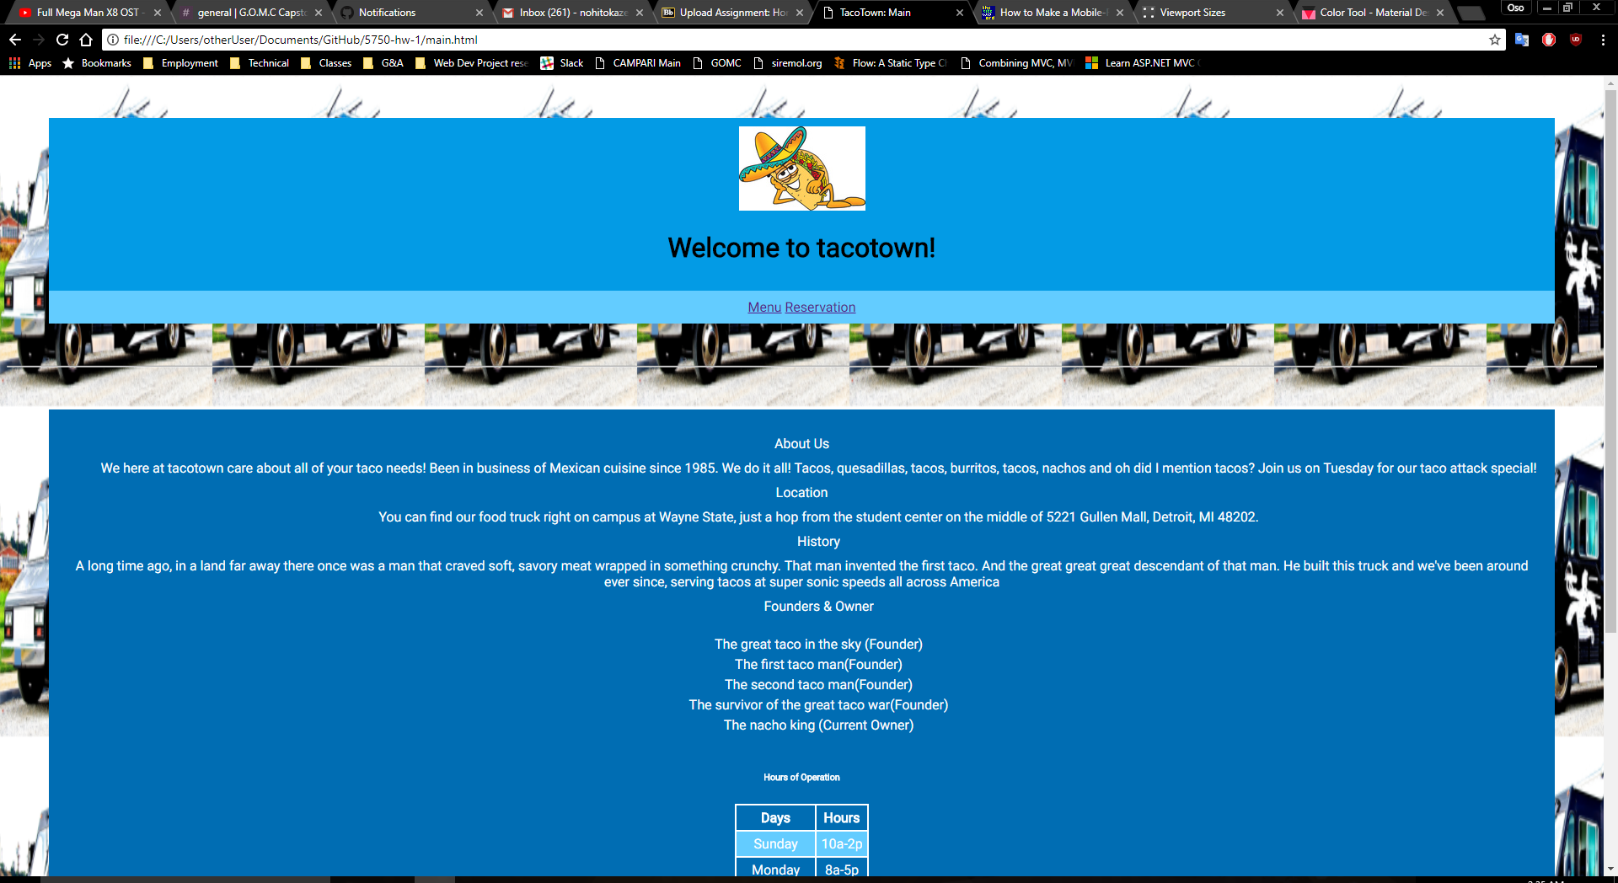

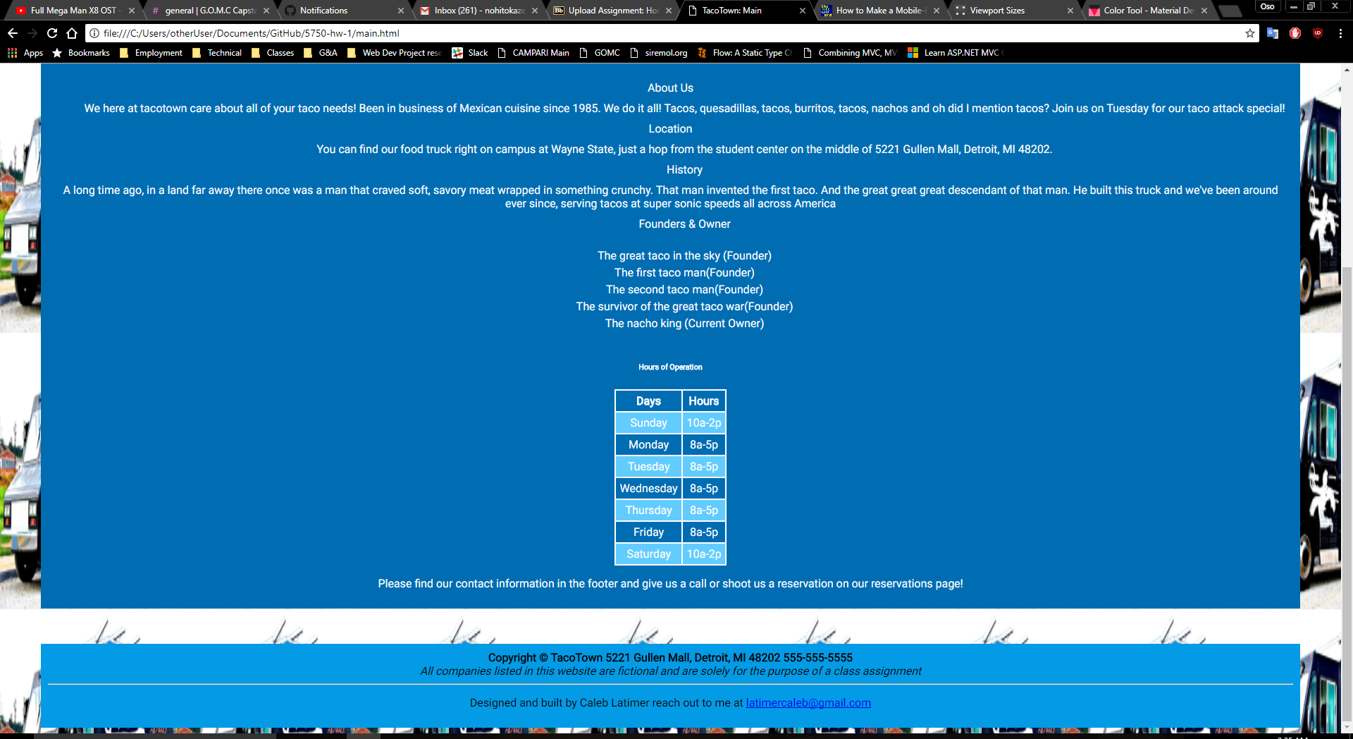

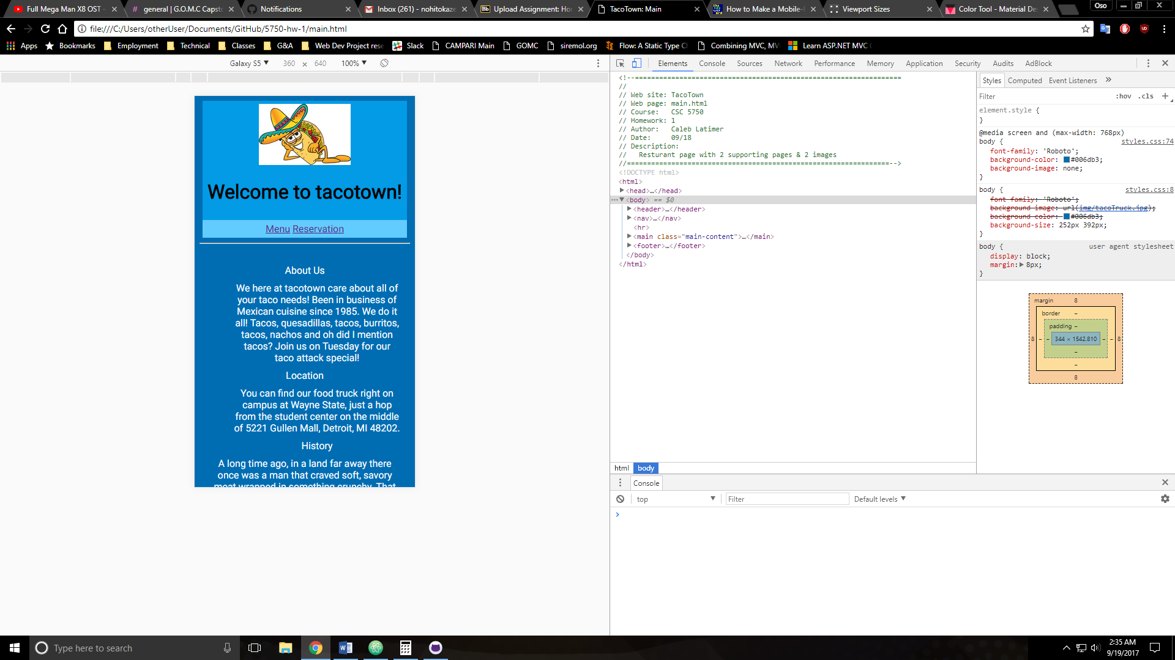

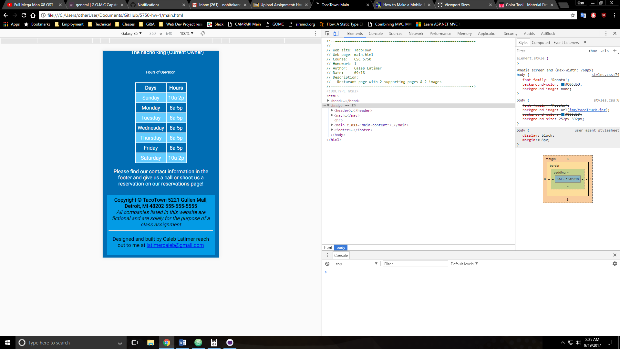

**Menu page**

**<!--==================================================================**

**//**

**// Web site: TacoTown**

**// Web page: menu.html**

**// Description: Menu page of taco town, maintains consistent header and footer of main page**

**//=================================================================-->**

**<!DOCTYPE html>**

**<html>**

**<head>**

**<title>Tacotown: Menu</title>**

**<link rel='stylesheet' type = 'text/css' href='css/styles.css' />**

**<meta name="viewport" content="width=device-width, initial-scale=1">**

**</head>**

**<body>**

**<header>**

**<img src='css/img/taco.jpg' alt='tacoMan picture'/>**

**<h1>Please find our menu below</h1>**

**</header>**

**<nav>**

**<a href = 'main.html'>Main</a>**

**<a href='reservation.html'>Reservation</a>**

**</nav>**

**<hr />**

**<main class='main-content'>**

**<span><a href='#mail'>To bottom</a></span>**

**<table>**

**<thead>Menu </thead>**

**<tr>**

**<th>Image</th>**

**<th>Dish</th>**

**<th>Description</th>**

**<th>Price</th>**

**</tr>**

**<tr>**

**<td><img src='css/img/tacoCombo.jpg' width='450' alt='taco picture'/></td>**

**<td>Taco Combo</td>**

**<td>3 tacos with the meat of your choosing with a side of salad,rice or beans</td>**

**<td>$10</td>**

**</tr>**

**<tr>**

**<td><img src='css/img/queasadillaCombo.jpg' width='450' alt='quesadilla picture'/></td>**

**<td>Quesadilla Combo</td>**

**<td>2 stuffed quesadillas with the meat of your choosing with a side of salad, rice or beans</td>**

**<td>$12</td>**

**</tr>**

**<tr>**

**<td><img src='css/img/burittoCombo.jpg' alt='burrito picture'/></td>**

**<td>Burrito Combo</td>**

**<td>1 stuffed 1.5 lbs burrito with the meat of your choosing with a side of salad, rice or beans</td>**

**<td>$12</td>**

**</tr>**

**<tr>**

**<td><img src='css/img/nachos.jpg' alt='nachos picture'/></td>**

**<td>Nachos</td>**

**<td>Fully loaded order of Nachos with meat, cheese, salsa, sour cream, avacado, bacon and jalape&ntilde;os </td>**

**<td>$12</td>**

**</tr>**

**<tr>**

**<td><img src='css/img/salad.jpg' width='450' alt='salad picture'/></td>**

**<td>Chopped</td>**

**<td>A healthy caesar salad with optional chicken, bacon and sunflower seeds</td>**

**<td>$8</td>**

**</tr>**

**</table>**

**<h6>We care about our customers!</h6>**

**<p>Special orders are available upon request</p>**

**<span><a href='#top'>To top</a></span>**

**</main>**

**<footer>**

**<b>Copyright &copy; TacoTown 5221 Gullen Mall, Detroit, MI 48202 555-555-5555</b><br />**

**<i>All companies listed in this website are fictional and are solely for the purpose of a class assignment</i><br />**

**<hr />**

**<p>Designed and built by Caleb Latimer reach out to me at <span id='mail'><a href="mailto:latimercaleb@gmail.com?subject=feedback">latimercaleb@gmail.com</a></span></p>**

**</footer>**

**</body>**

**</html>**

**If possible, format your code like this:**

**Font “Courier New”**

**Font size “9”**

**Bold**

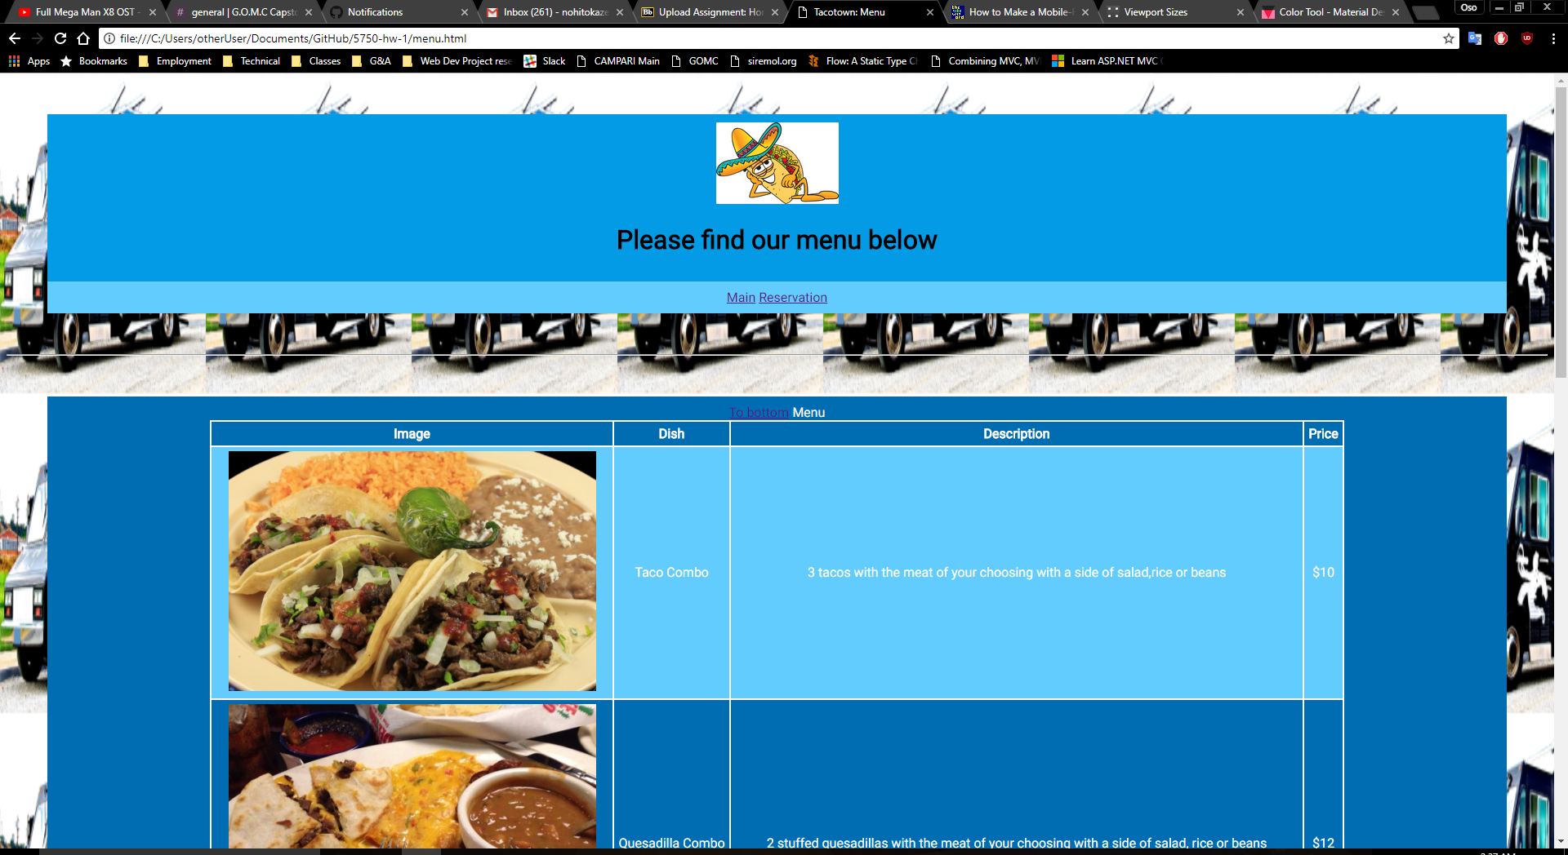

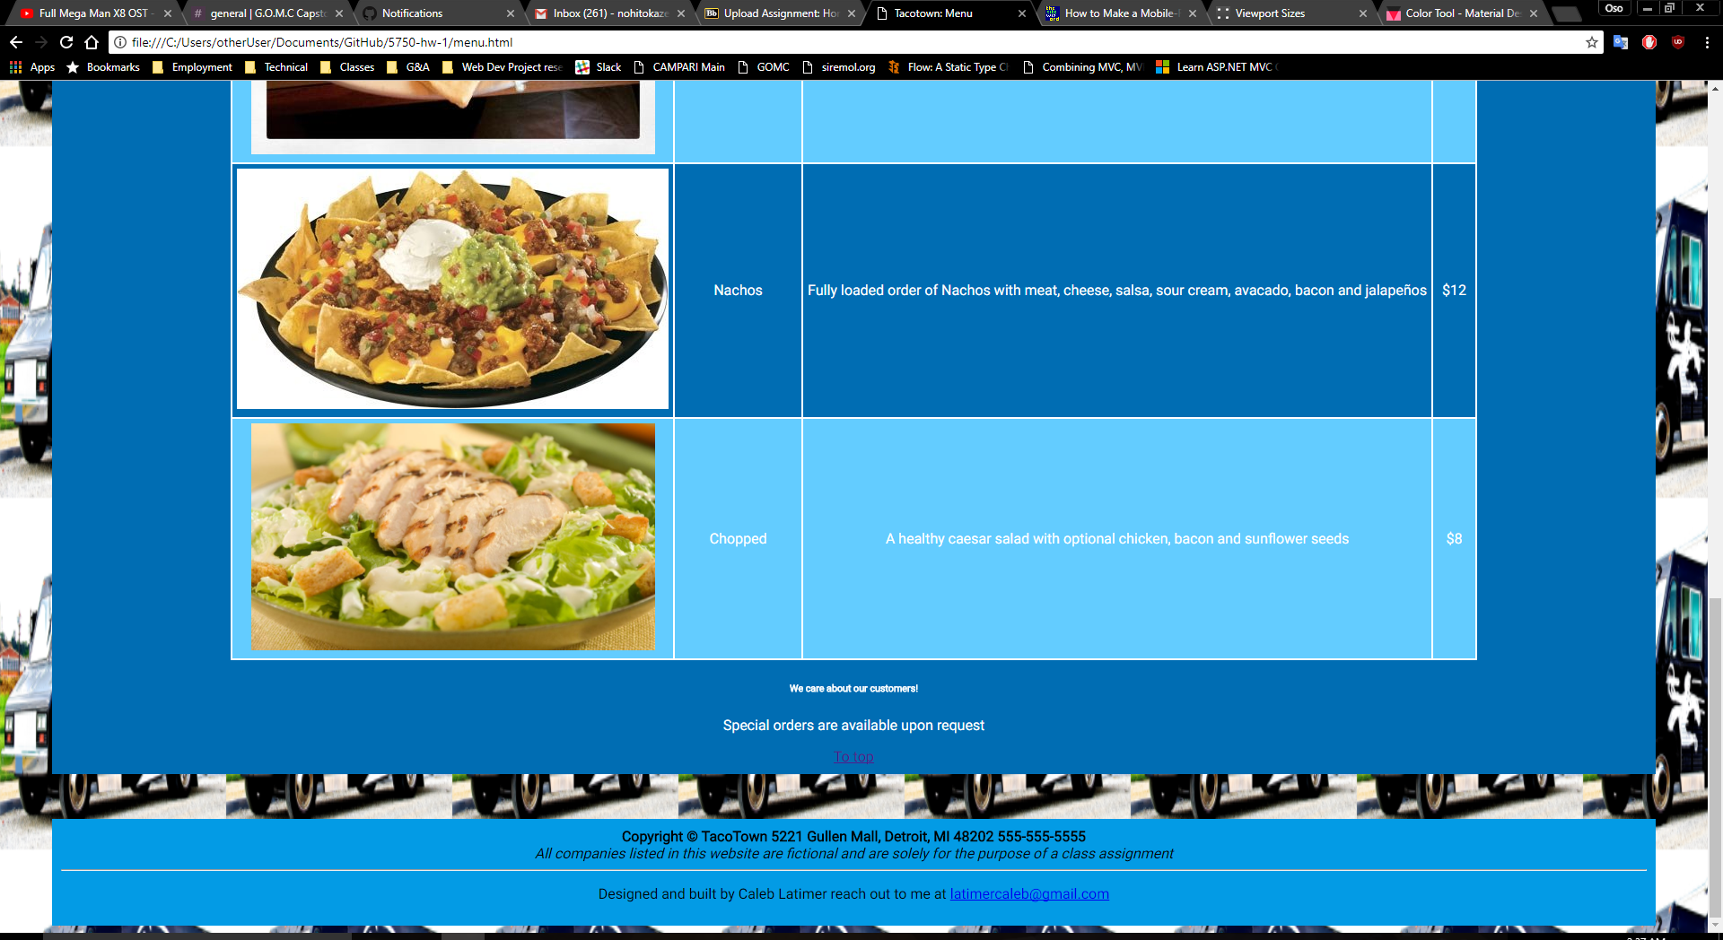

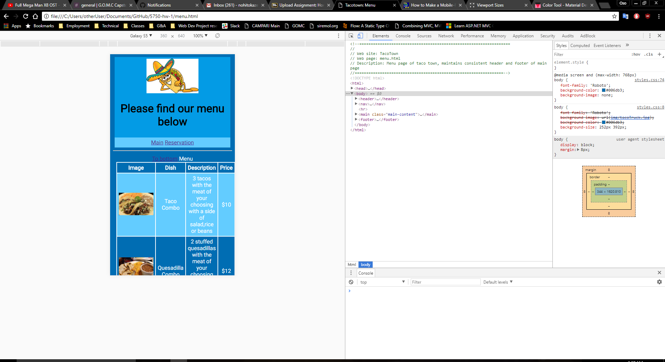

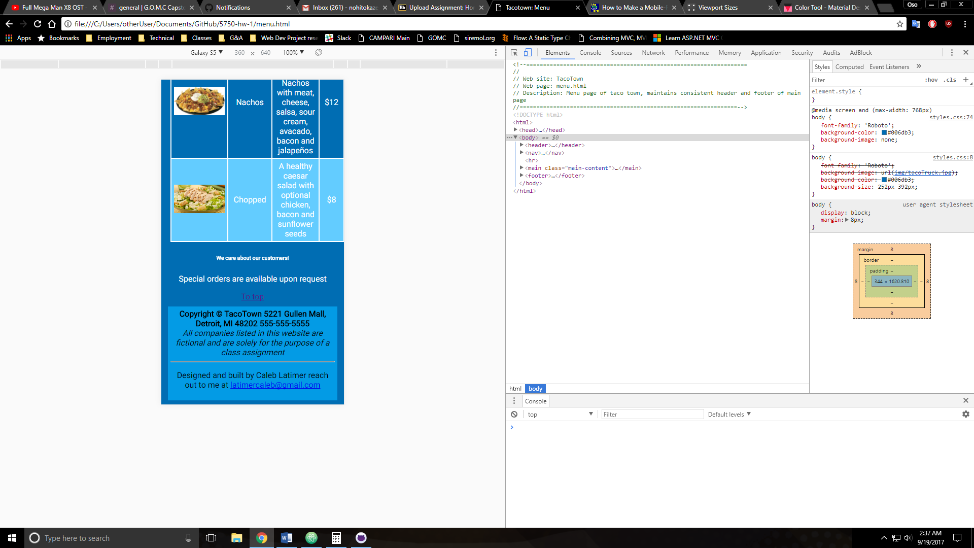

**Reservation page**

**<!--==================================================================**

**//**

**// Web site: TacoTown**

**// Web page: reservation.html**

**// Description: Form controls for scheduling reservations of groups**

**//=================================================================-->**

**<!DOCTYPE html>**

**<html>**

**<head>**

**<title>Tacotown: Reservations</title>**

**<link rel='stylesheet' type = 'text/css' href='css/styles.css' />**

**<meta name="viewport" content="width=device-width, initial-scale=1">**

**</head>**

**<body>**

**<header>**

**<img src='css/img/taco.jpg' alt='tacoMan picture'/>**

**<h1>Carryout or eat in!</h1>**

**</header>**

**<nav>**

**<a href = 'main.html'>Main</a>**

**<a href='menu.html'>Menu</a>**

**</nav>**

**<hr />**

**<main class='main-content'>**

**<p>We support group accomadations for our dine in tables, feel free to reserve a space here</p>**

**<form method='get' action='http://www.tipjar.com/cgi-bin/test'>**

**<label>Party Name:</label>**

**<input type='text' name='partyName' required/><br />**

**<label>Date:</label>**

**<input type='date' name='reservationDate' required/><br />**

**<label>Part of the day:</label>**

**<input type='radio' name='partOfDay' value="morning">Morning**

**<input type='radio' name='partOfDay' value="afternoon">Afternoon**

**<input type='radio' name='partOfDay' value="evening">Evening</br/>**

**<label>Time slot: </label>**

**<input type='radio' name='timeSlot' value='1'/>1**

**<input type='radio' name='timeSlot' value='2'/>2**

**<input type='radio' name='timeSlot' value='3'/>3<br />**

**<label>Number in your party: </label>**

**<input type='number' required/><br />**

**<label>E-mail address: </label>**

**<input type='email' name='email' required/><br />**

**<label>Cell Phone: </label>**

**<input type='tel' required/><br />**

**<input type='reset' />**

**<input type='submit' value='Submit Reservation' />**

**</form>**

**<h6>Expect a response in 48 hours or get a 25% discount!</h6>**

**</main>**

**<footer>**

**<b>Copyright &copy; TacoTown 5221 Gullen Mall, Detroit, MI 48202 555-555-5555</b><br />**

**<i>All companies listed in this website are fictional and are solely for the purpose of a class assignment</i><br />**

**<hr />**

**<p>Designed and built by Caleb Latimer reach out to me at <span id='mail'><a href="mailto:latimercaleb@gmail.com?subject=feedback">latimercaleb@gmail.com</a></span></p>**

**</footer>**

**</body>**

**</html>**

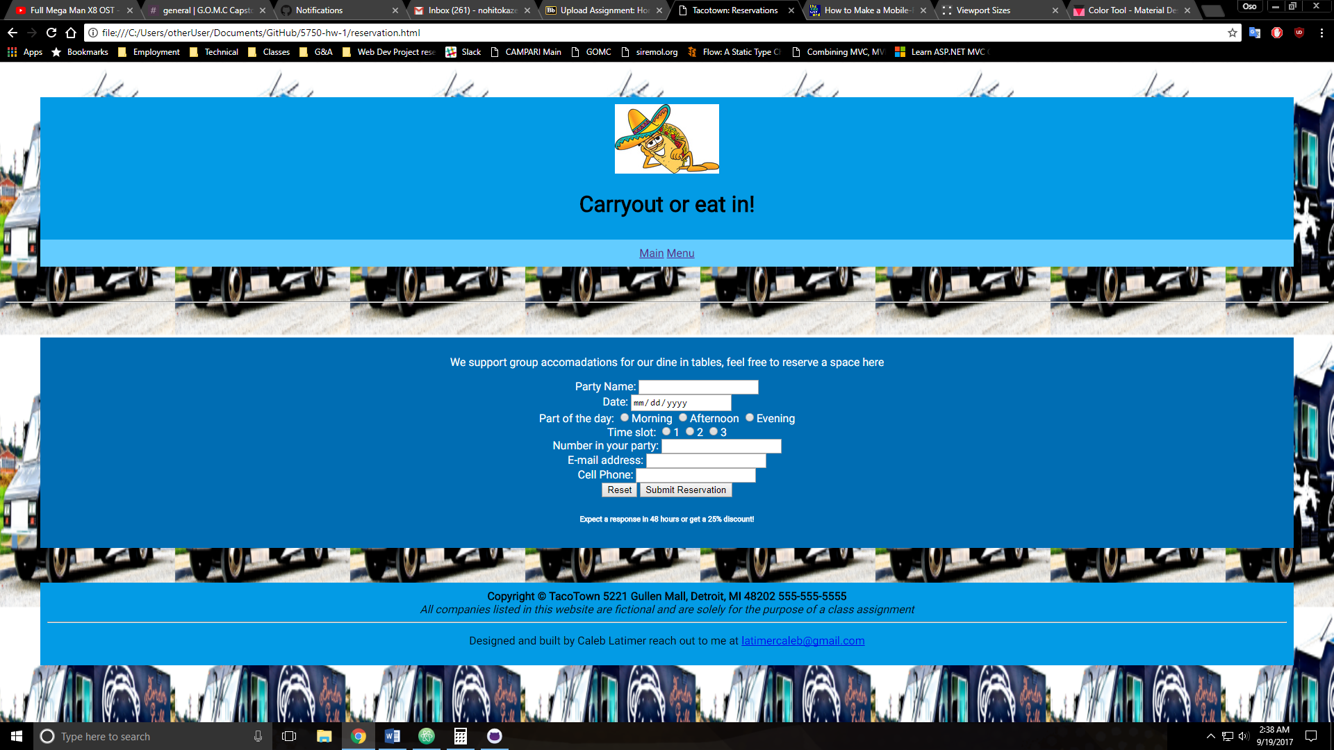

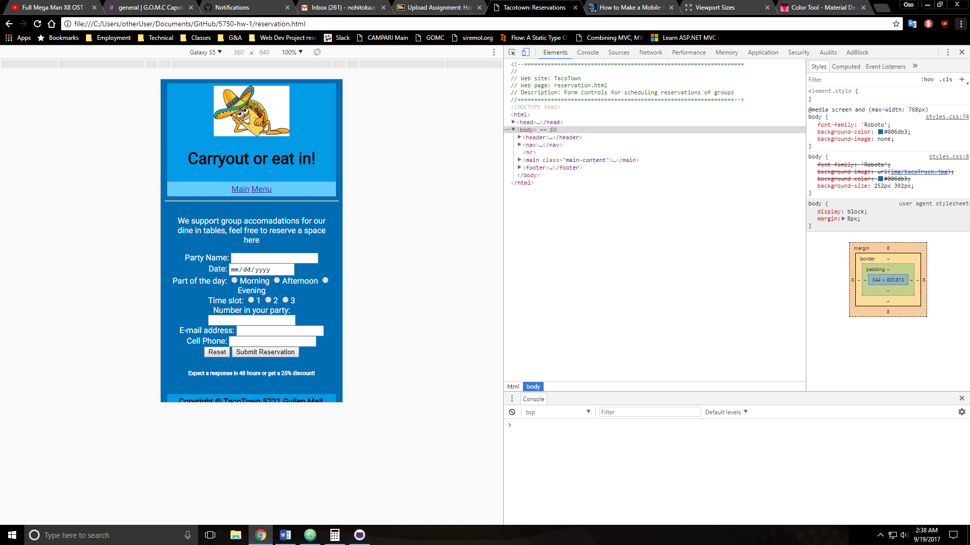

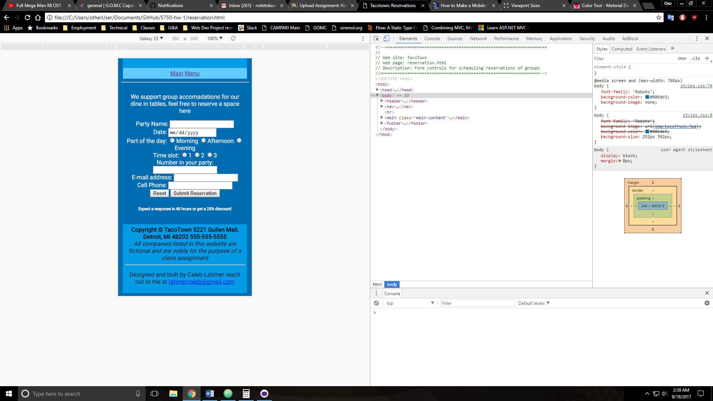

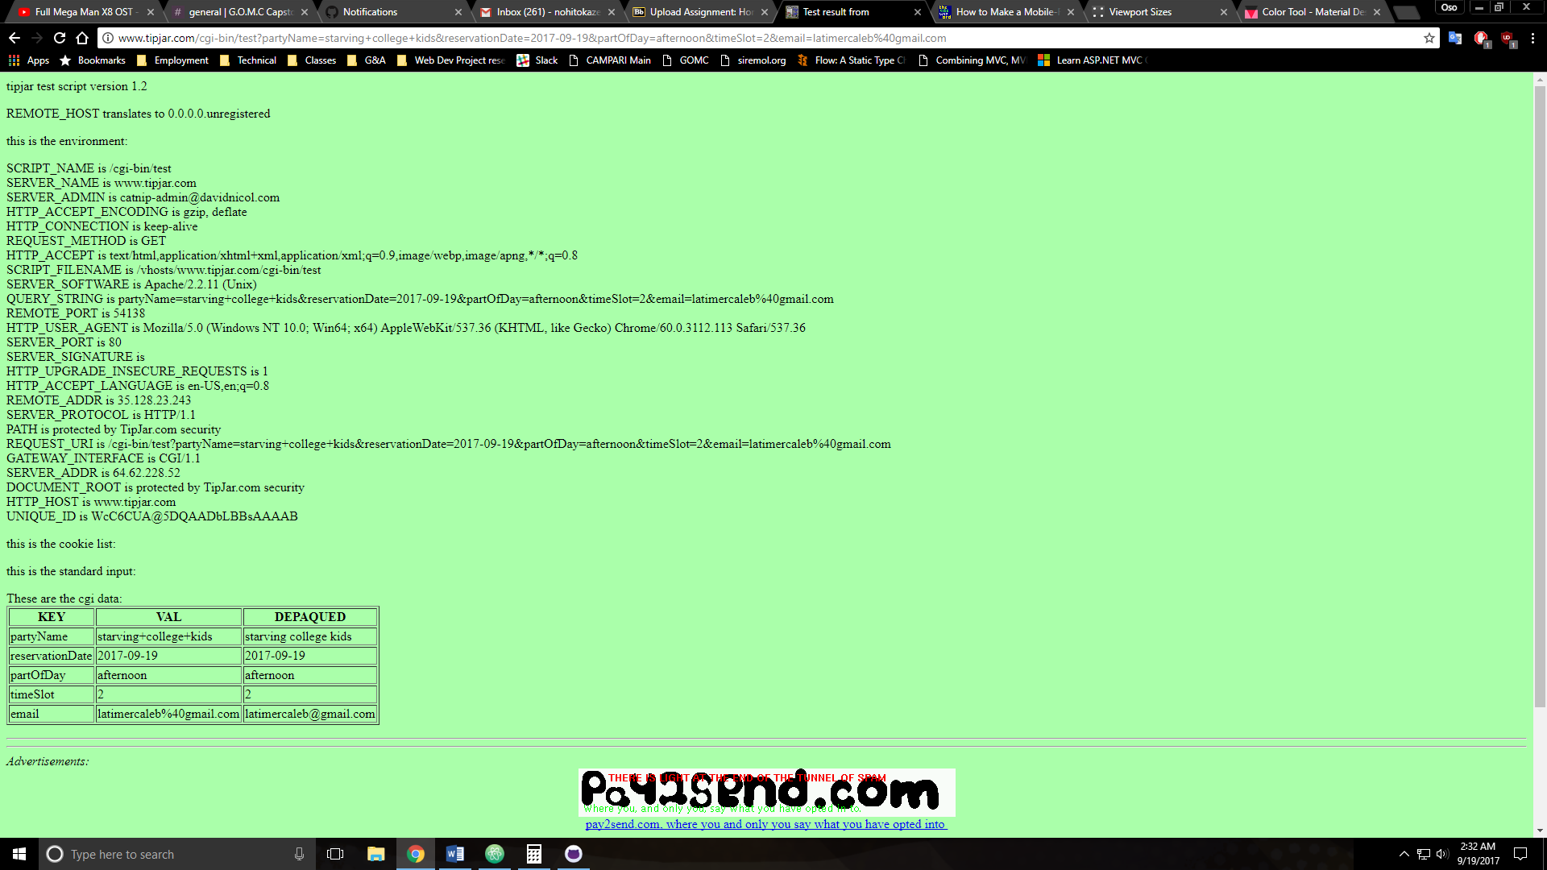

**Style Sheet**

**/*styles.css**

**Web site: TacoTown**

**Web page: All**

**Description: Styling for tacotown, roboto custom font from google imported, mobile media query for responsive design implemented, color scheme designed with google material design color picker https://material.io/color/#!/?view.left=0&view.right=0&primary.color=039BE5**

**Images found by google search**

**\*/**

**@import url('https://fonts.googleapis.com/css?family=Roboto');**

**body {**

**font-family: 'Roboto';**

**background-image: url("img/tacoTruck.jpg");**

**background-color: #006db3;**

**background-size: 252px 392px;**

**}**

**header,footer {**

**background-color: #039be5;**

**color: #000000;**

**text-align: center;**

**margin: 50px 50px 0px 50px;**

**padding: 10px;**

**}**

**nav {**

**background-color: #63ccff;**

**color: #FFFFFF;**

**text-align: center;**

**margin: 0px 50px 50px 50px;**

**padding: 10px;**

**}**

**.main-content {**

**background-color: #006db3;**

**color: #FFFFFF;**

**text-align: center;**

**margin: 50px;**

**padding: 10px;**

**}**

**#mail:hover {**

**background-color: #FFFFFF;**

**border: 2px solid black;**

**border-radius: 2px;**

**}**

**dd {**

**font-weight: 500;**

**padding: 5px;**

**}**

**dt {**

**padding: 5px;**

**}**

**li {**

**list-style-type: none;**

**margin: 5px;**

**}**

**table {**

**margin: auto;**

**border-collapse: collapse;**

**}**

**table,tr,th,td {**

**border: 2px solid #FFFFFF;**

**padding: 5px;**

**}**

**tr:nth-child(even){**

**background-color: #63ccff;**

**}**

**@media screen and (max-width: 768px) {**

**@import url('https://fonts.googleapis.com/css?family=Roboto');**

**body {**

**font-family: 'Roboto';**

**background-color: #006db3;**

**background-image: none;**

**}**

**header,footer {**

**background-color: #039be5;**

**color: #000000;**

**text-align: center;**

**margin: 5px 5px 0px 5px;**

**padding: 5px;**

**}**

**nav {**

**background-color: #63ccff;**

**color: #FFFFFF;**

**text-align: center;**

**margin: 0px 5px 5px 5px;**

**padding: 5px;**

**}**

**.main-content {**

**background-color: #006db3;**

**color: #FFFFFF;**

**text-align: center;**

**margin: 5px;**

**padding: 5px;**

**}**

**#mail:hover {**

**background-color: #FFFFFF;**

**border: 2px solid black;**

**border-radius: 2px;**

**}**

**dd {**

**font-weight: 500;**

**padding: 5px;**

**}**

**dt {**

**padding: 5px;**

**}**

**li {**

**list-style-type: none;**

**margin: 5px;**

**}**

**table {**

**margin: auto;**

**border-collapse: collapse;**

**}**

**table,tr,th,td {**

**border: 2px solid #FFFFFF;**

**padding: 5px;**

**}**

**tr:nth-child(even){**

**background-color: #63ccff;**

**}**

**td img{**

**width: 100px;**

**}**

**}**

* **Copying-and-pasting web page code to a Word document**

1) From the HTML editor window, press **CTRL-A** and press **CTRL-C**.

2) From within the Word document, press **CTRL-V**.

** **Copying-and-pasting application output to a Word document**

1) From the web page, maximize the browser window.

2) From the browser window, press **ALT-PrintScreen**.

3) From within the Word document, press **CTRL-V**.